DATE:04/02/26
EXPERIMENT:1
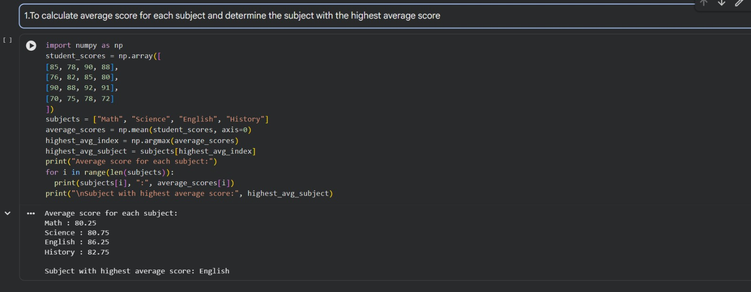
EXPERIMENT2:

